**LAB PRACTICAL DAY 5**

**Check If All 1's Are at Least Length K Places Away**

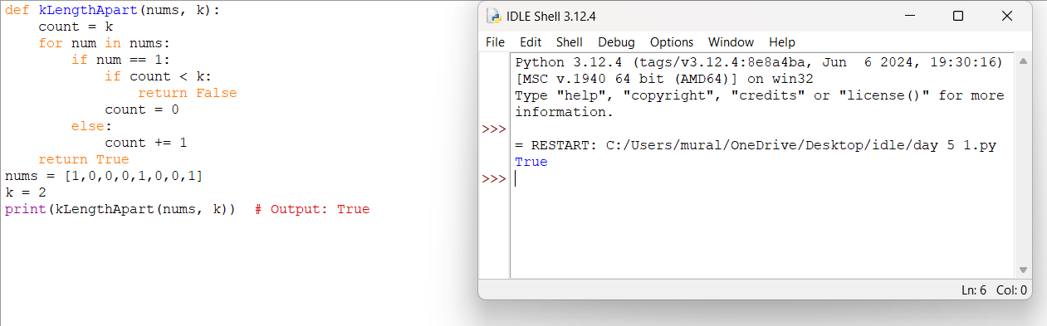

**Longest Continuous Subarray With Absolute Diff Less Than or Equal to Limit**

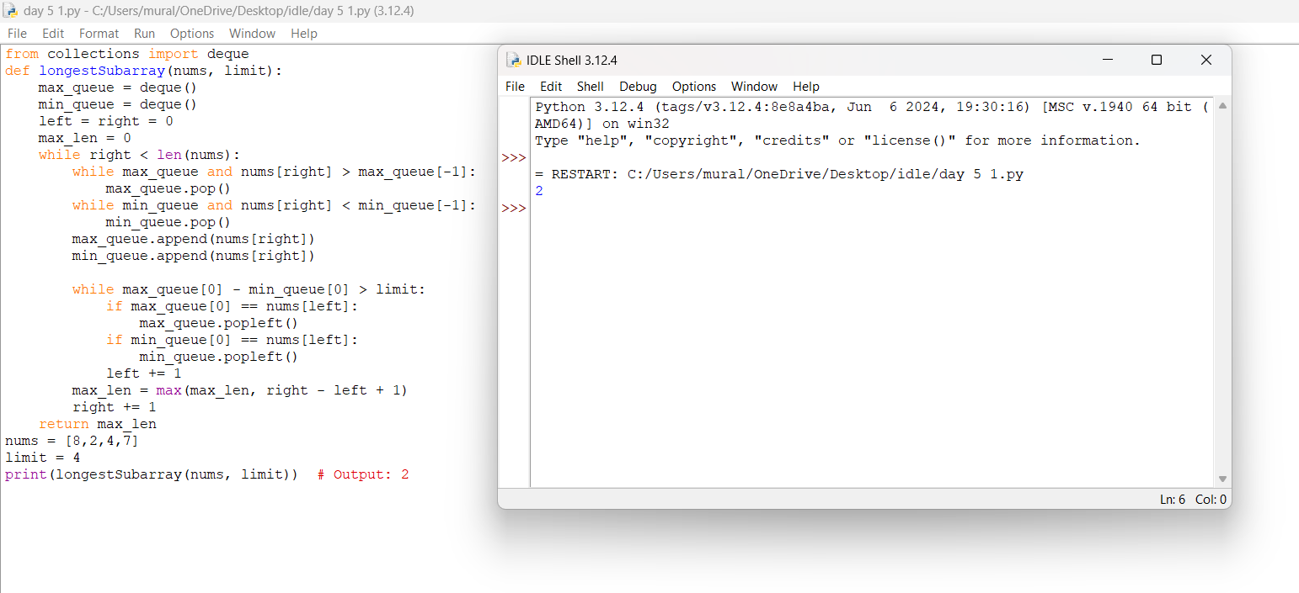

**Find the Kth Smallest Sum of a Matrix With Sorted Rows**

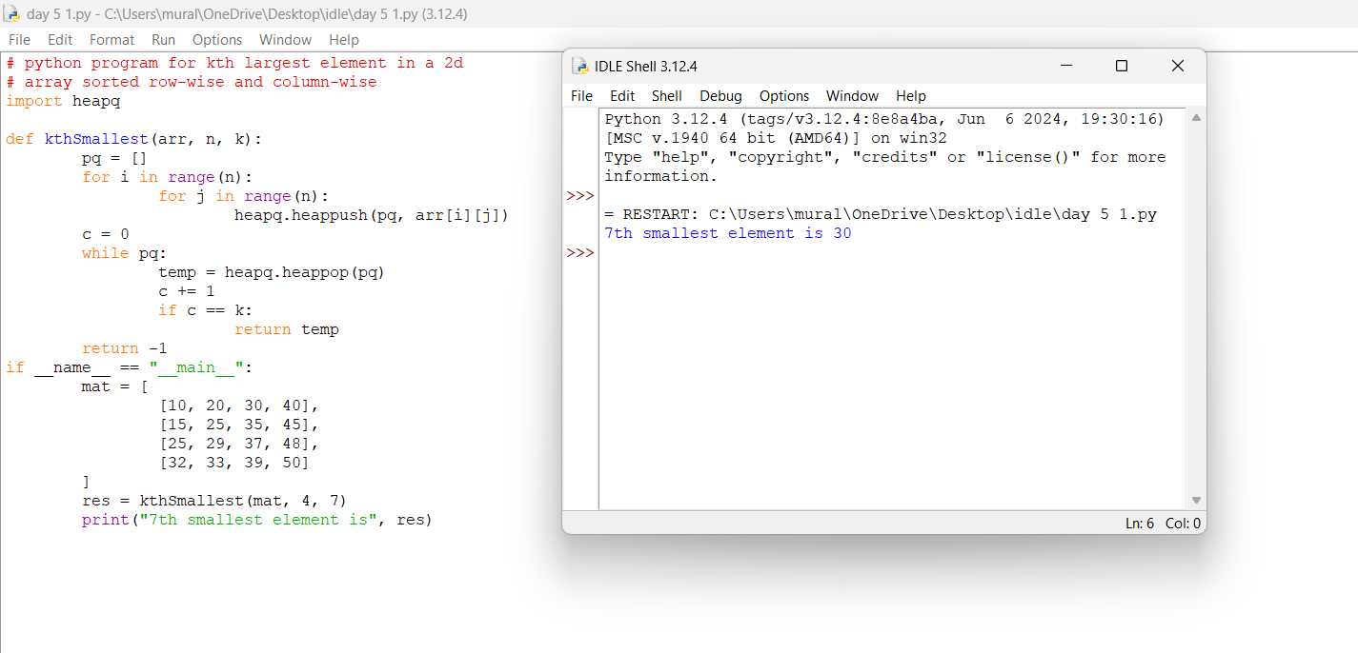

**Evaluate Boolean Expression**

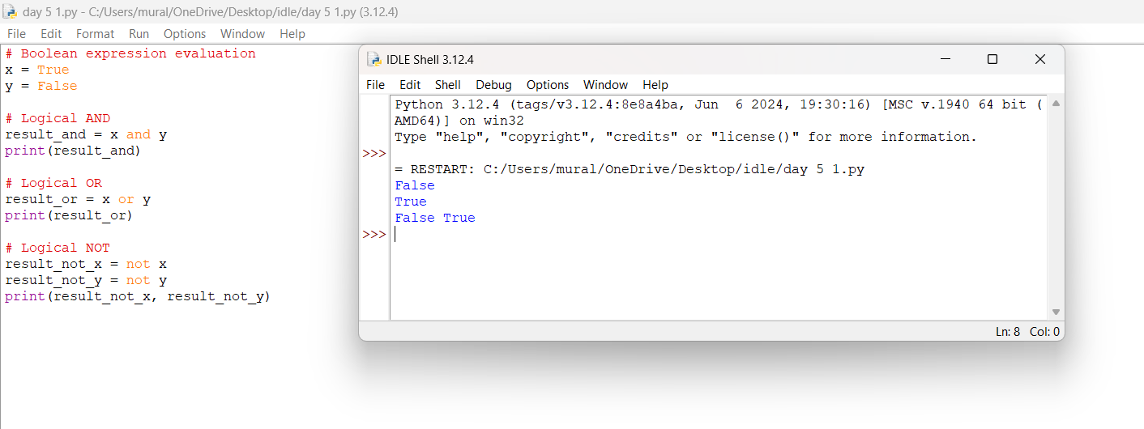

**Build an Array With Stack Operations**

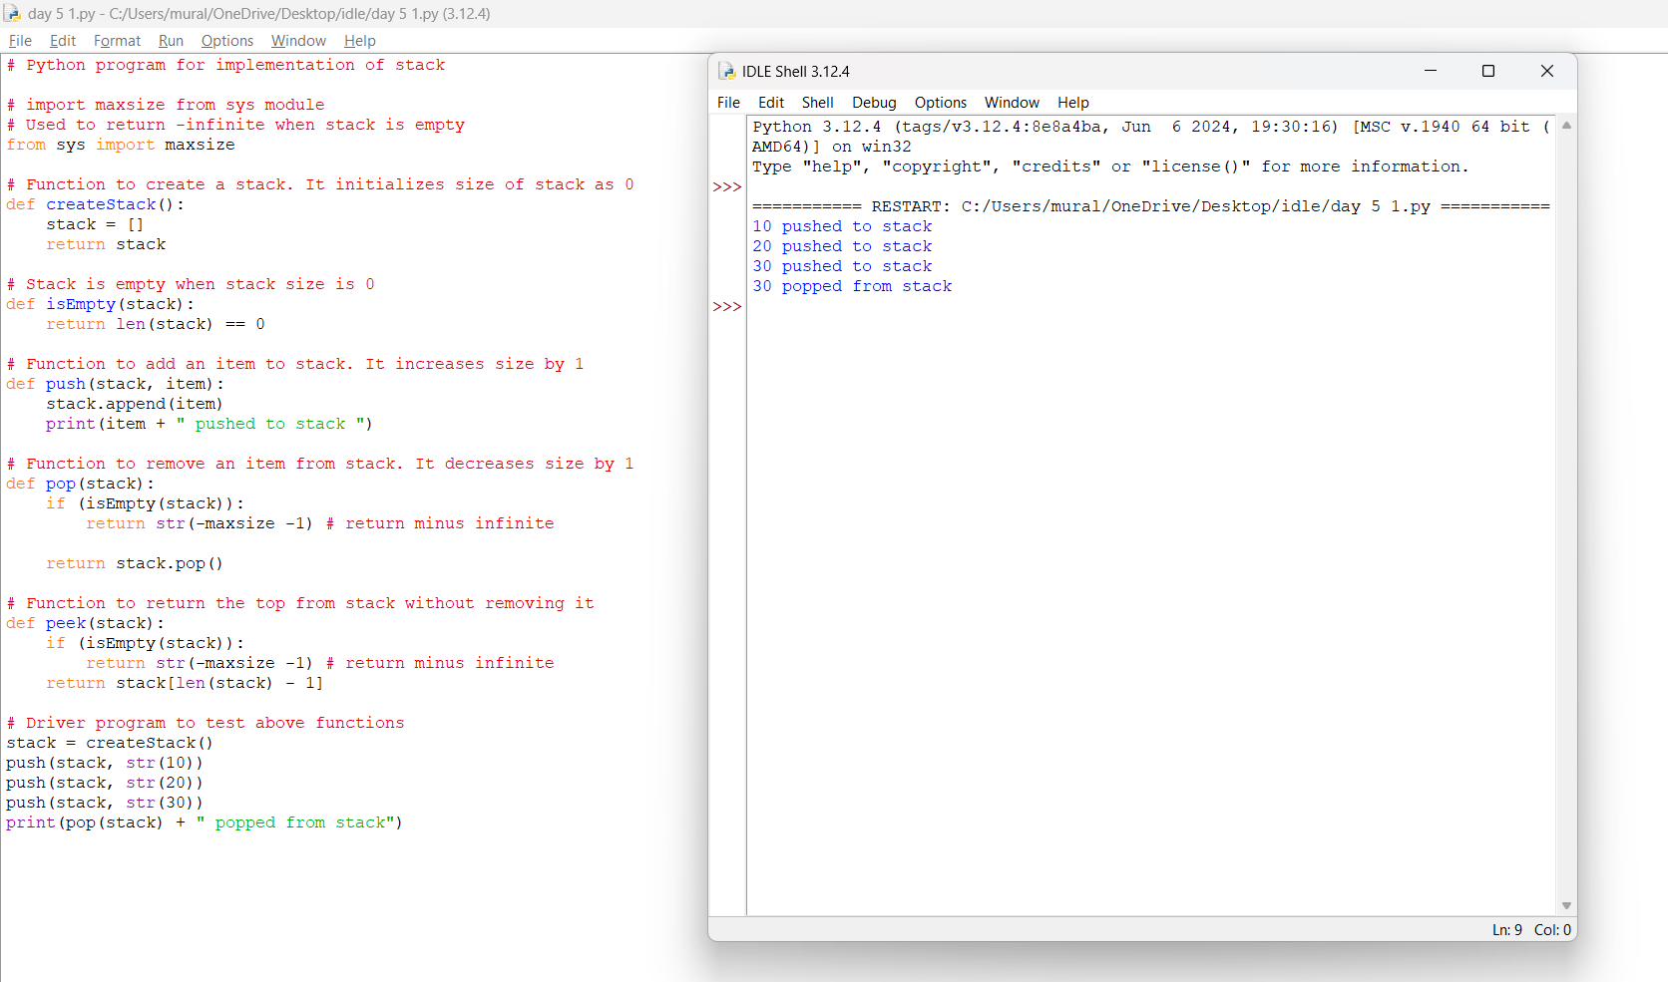

**Count Triplets That Can Form Two Arrays of Equal XOR**

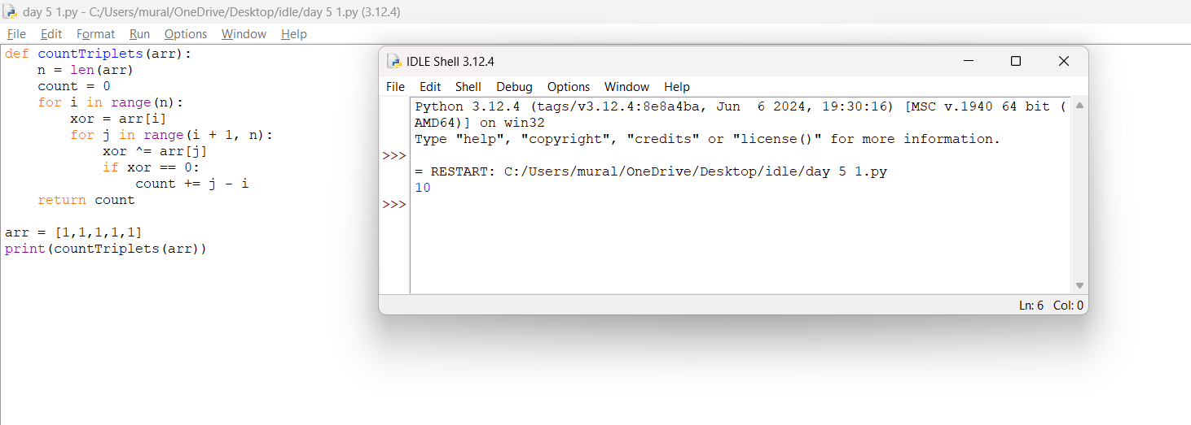

**Minimum Time to Collect All Apples in a Tree**

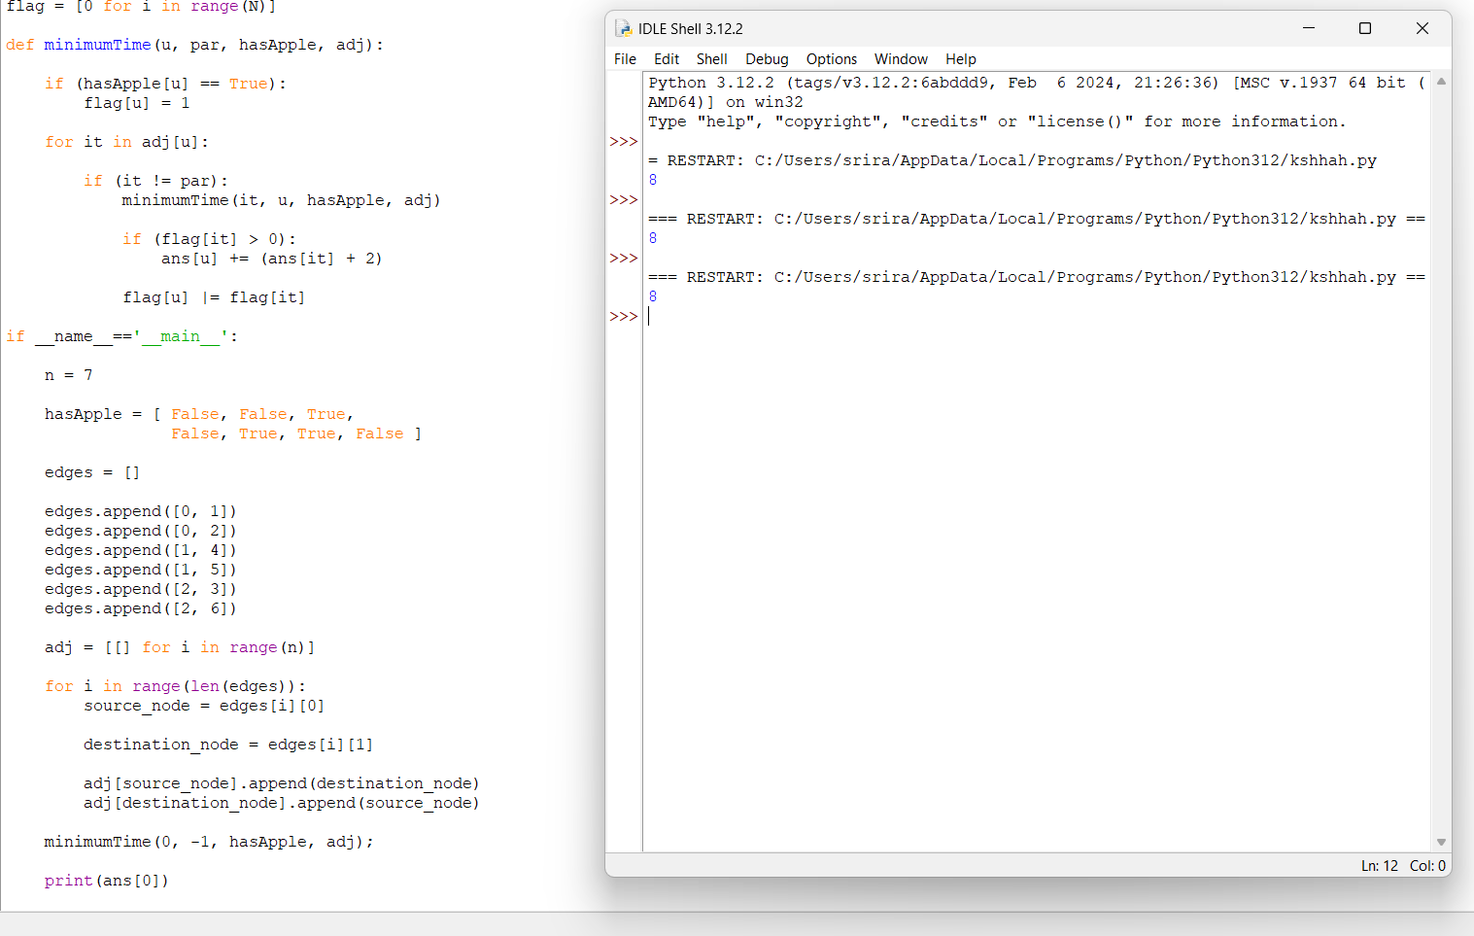

**Number of Ways of Cutting a Pizza**

